AI GRAMMER CHECKER
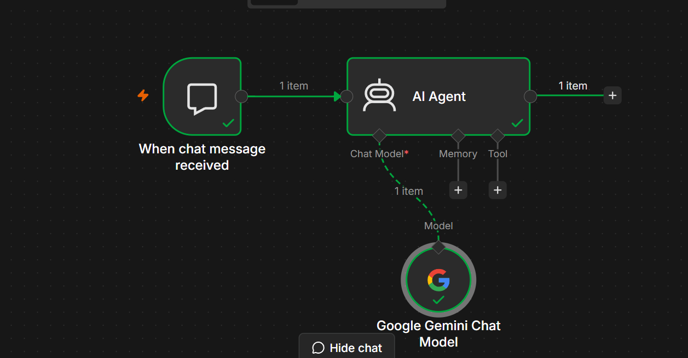
Project Objective
The objective of this project is to build an AI-powered Email Writer that generates professional, well-structured emails based on the user's instructions.
The AI Agent can generate:
- Professional business emails
- Formal emails
- Casual emails
- Follow-up emails
- Job application emails
- Leave request emails
- Thank-you emails
- Customer support emails

Workflow Architecture
User
│
▼
When Chat Message Received
│
▼
AI Agent
│
▼
Google Gemini Chat Model
│
▼
Generated Email

Project Workflow
This workflow consists of 3 nodes.
Step | Node | Purpose
1 | When Chat Message Received | Receives the user's request
2 | AI Agent | Understands the email requirements
3 | Google Gemini Chat Model | Generates the email

Prerequisites
Before building this project, ensure you have:
- n8n Cloud or Self-hosted
- Google AI Studio API Key
- Google Gemini Chat Model configured
- Internet connection

Step 1 – Create a New Workflow
Open n8n
Click
New Workflow
Rename it
AI Email Writer

Step 2 – Add Chat Trigger
Add the node
When Chat Message Received
Purpose
Starts the workflow whenever a user sends a request.
Example Input
Write a professional email requesting leave for two days because I have a family function.
Output
{
"chatInput":"Write a professional email requesting leave for two days because I have a family function."
}

Step 3 – Add AI Agent
Connect
When Chat Message Received
│
▼
AI Agent
Configure
Source for Prompt
Connected Chat Trigger Node
Prompt
{{$json.chatInput}}

Step 4 – Configure the System Prompt
Paste the following into the System Message.
You are an AI Email Writer.

Your task is to write clear, professional, and well-structured emails based on the user's request.

Instructions:

- Understand the purpose of the email.
- Use an appropriate greeting.
- Write in a polite and professional tone unless the user requests otherwise.
- Organize the email into introduction, body, and closing.
- Keep the email concise while including all important details.
- End with an appropriate closing such as "Regards" or "Thank you."
- If the user does not provide enough information, make reasonable assumptions and note them naturally in the email.
- Return only the email unless the user asks for an explanation.

Step 5 – Add Google Gemini Chat Model
Click
+ Chat Model
Select
Google Gemini Chat Model
Configure
Setting | Value
Provider | Google Gemini
Model | Gemini 2.5 Flash (or another available Gemini model)
Authentication | Google AI Studio API Key
Connect it to the AI Agent.

Final Workflow
When Chat Message Received
│
▼
AI Agent
│
▼
Google Gemini Chat Model

Workflow Execution
Step 1
User enters
Write a formal email to my manager requesting work from home for tomorrow due to a medical appointment.
↓
Step 2
Chat Trigger captures the request.
↓
Step 3
AI Agent receives the prompt.
↓
Step 4
The AI Agent sends the prompt to the Google Gemini Chat Model.
↓
Step 5
Gemini generates a professional email.
↓
Step 6
The completed email is returned to the user.

Sample Inputs and Outputs
Example 1
Input
Write a leave request email for two days.
Output
Subject: Leave Request

Dear Manager,

I hope you are doing well.

I would like to request leave for two days due to a family function. I will ensure that my current tasks are completed before my leave and will be available for urgent matters if needed.

Thank you for your understanding.

Kind regards,
[Your Name]

Example 2
Input
Write a thank-you email after a job interview.
Output
Subject: Thank You for the Interview

Dear Hiring Manager,

Thank you for taking the time to interview me today. I enjoyed learning more about the role and your team. I appreciate the opportunity and look forward to hearing from you.

Kind regards,
[Your Name]

Example 3
Input
Write an email apologizing for submitting a report late.
Output
Subject: Apology for Late Report Submission

Dear Sir/Madam,

I sincerely apologize for submitting the report later than expected. I understand the importance of meeting deadlines and appreciate your patience. I will take additional care to ensure timely submissions in the future.

Thank you for your understanding.

Regards,
[Your Name]

Workflow Diagram
User
│
▼
When Chat Message Received
│
▼
AI Agent
│
▼
Google Gemini Chat Model
│
▼
Generated Email

Error Handling
Error: No Prompt Specified
Cause
The AI Agent did not receive any user input.
Solution
Ensure the AI Agent is connected to the When Chat Message Received node and uses:
{{$json.chatInput}}

Error: Authentication Failed
Cause
The Google Gemini API key is invalid or expired.
Solution
Update the API credentials in the Google Gemini Chat Model node.

Error: Too Many Requests
Cause
The Gemini API request limit has been exceeded.
Solution
- Wait a few minutes before retrying.
- Check your Google AI Studio API quota.
- Upgrade your API plan if necessary.

Learning Outcomes
After completing this project, you will be able to:
- Build an AI Email Writer using n8n.
- Connect an AI Agent with Google Gemini.
- Create effective system prompts for email generation.
- Generate professional emails from natural language requests.
- Test and debug conversational AI workflows.

Real-World Applications
- Business email drafting.
- Customer support responses.
- HR and recruitment communication.
- Job application emails.
- Leave requests.
- Meeting invitations.
- Follow-up emails.
- Thank-you emails.
- Client communication.

Practice Challenge
Enhance this project by adding:
- An email tone selector (Formal, Friendly, Professional, Persuasive).
- An email length option (Short, Medium, Detailed).
- Automatic subject line generation.
- A Memory node to remember the user's preferred writing style.
- A Gmail node to send the generated email automatically.
- A Google Sheets node to log generated emails.

Final Workflow
User
│
▼
When Chat Message Received
│
▼
AI Agent
│
▼
Google Gemini Chat Model
│
▼
Professional Email
Expected Result
The AI Email Writer accepts a user's request through the chat interface, sends it to the Google Gemini Chat Model, and generates a well-formatted email with an appropriate subject, greeting, body, and closing. This project helps you learn prompt design and AI-assisted content generation and provides a foundation for building more advanced email automation workflows in n8n, such as integrating Gmail to send the generated emails automatically.

